Tuning

Rollers.
A central bolt of the roller of Piper 1 is at the same time tuning mechanism. To increase tension with the pipe tighten the central bolt, to decrease let it free. Rollers Should be sliding on pipes with a small tension. All ballbearing should rotate during the move.
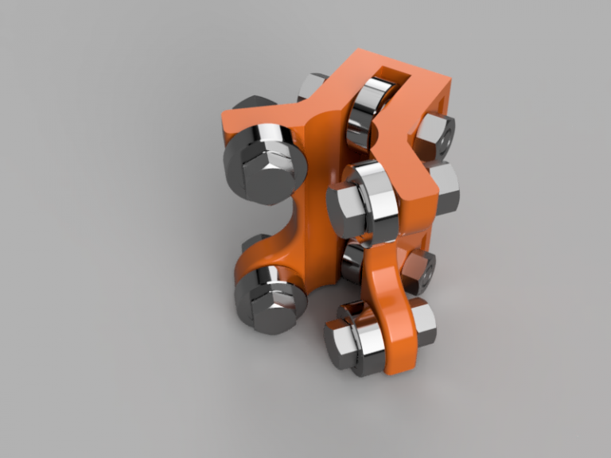

Z axis.
After assembling the frame check that Z pipe is vertical. You may use any tool which allows measuring 90 degrees. Make necessary adjustments.
Make sure that Z rollers are tuned according to above instructions.
Untight top corner brackets on a pipe which is parallel to X-axis.
Move X gantry to the top position and temporary tie it to the top pipe (using rope or wire).
Tighten corner brackets.

Z Rods
If you already connected rods to Z motors couplings remove them.
Move X gantry to the lowest position and check that Z rods (lead screw/ACME screw) are aligned with motor shafts. To adjust alignment you may move motor left right.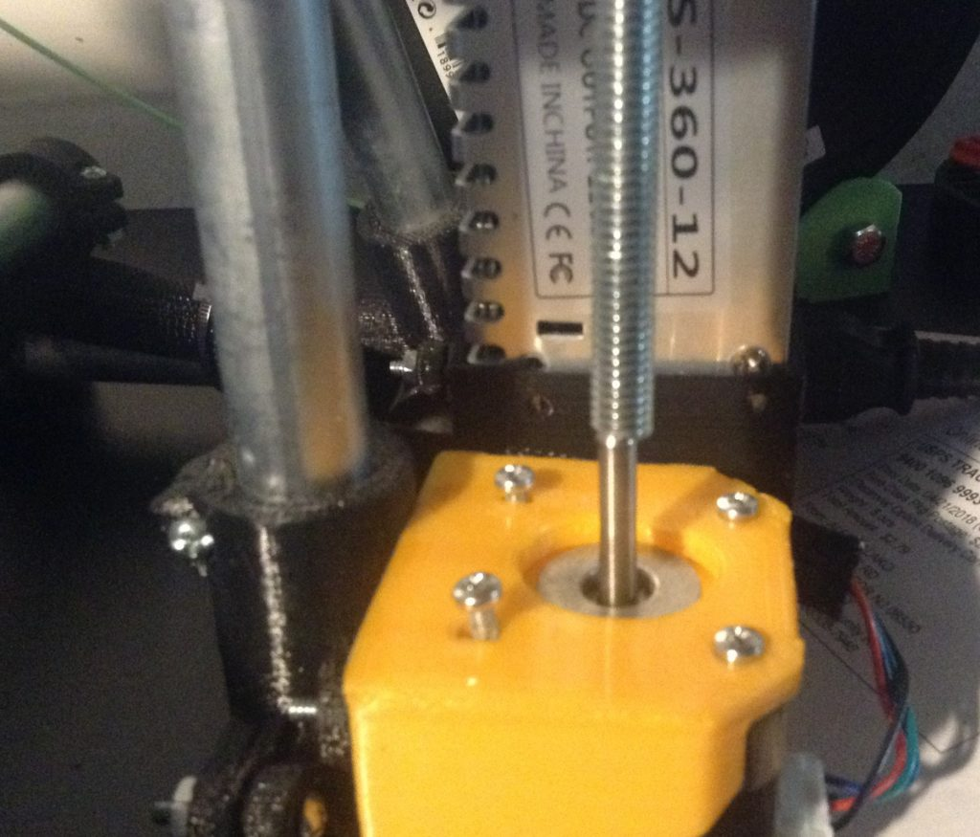
Once rods are aligned with motors you may attach pineapple coupling.

